**APPLICATION FORM FOR THE PARTICIPANTS OF THE NODEM CONFERENCE**

**ACCOMMODATION AT THE SOFITEL WARSAW VICTORIA HOTEL**

**30.11.2014 – 4.12.2014**

**Classic Single Room PLN 300 + vat per night, breakfast included**

**Classic Double Room PLN 350 + vat per night, breakfast included**

Above rates are in PLN for one room and one night. Rates are inclusive of breakfast in Restaurant and exclusive of VAT tax (currently 8% subject to change*). Room rates include free of charge high-speed internet access and unlimited access to the recreation centre (pool, fitness, hammam).

Check in time: from 2.00 p.m., check out time 12.00 a.m.

Family name**_______________________________________________________________________**

First name**_________________________________________________________________________**

Address**__________________________________________________________________________**

Phone number**_____________________________________________________________________**

Fax number **_______________________________________________________________________**

E- mail**___________________________________________________________________________**

Dates of reservation: from to

Type of room:

Single Twin

smoking room non-smoking room

Form of payment:

credit card

Name, number and expiry date of credit card: ___________________________________________________

**Please note that Hotel will accept the reservation only with a credit card number (or prepayment) as a guarantee.**

**Rooms can be cancelled without any charge till 16.11.2014. For any cancellation after this date guest will be charged for the whole stay.**

Please kindly send back this application form to the Reservation Department of Sofitel Warsaw Victoria Hotel (fax number: +48 22 657 81 69 or e-mail: [H3378-RE@sofitel.com](mailto:H3378-RE@sofitel.com)) until 15.11.2014.

We thank you very much for choosing Sofitel Warsaw Victoria and we wish you a magnifique stay in our hotel!

*\* In the event of changes to VAT values resulting from new taxing regulations an additional VAT charge, will be added to the net prices, according to the official VAT value of the day of the stay.*

**Confirmation number: Hotel’s signature:**

**Classic Rooms**

The spacious, air-conditioned rooms with individual monitoring have been designed especially for business and individual travelers. They all feature the luxury “MyBed” - Sofitel exclusivity for a perfect sleep, safe, mini-bar, pay-TV, coffee/tea facilities, mineral water, and the latest technology, including complimentary high-speed internet access. The bathroom features French Lanvin Cosmetics.

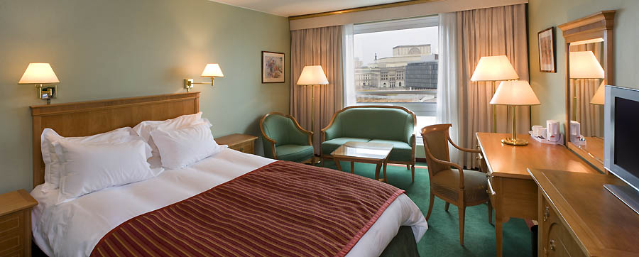

**Breakfast**

Our Executive Chef – Maciej Majewski invites you to a wealthy breakfast buffet, with Polish specialties as well as French patisserie, a large selection of warm and cold dishes, fresh juices. Enjoy a real breakfast feast and start the day with a smile.





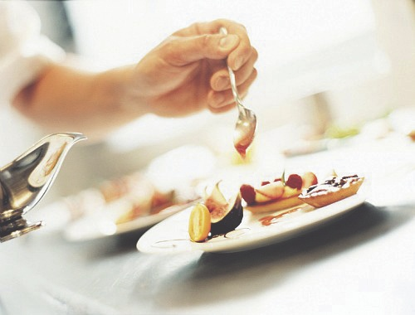

**Leisure**

The Recreation Centre is an extraordinary place in the hotel. The beautifully designed swimming pool, Fitness and hammam are an encouragement to relax and naturally replenish your energy. Guests of the Hotel have unlimited access to it.

